Name:  Teacher: | ____________________________________  ______________________ |  | Date: _________
 | Year 9 2018  / 58  End of Term 1 Test  Full working out MUST be shown to get full marks for each question.
Total Time: | 55 minutes
Weighting: | 9%
Equipment: | To be provided by the student: Pen, pencil, ruler, scientific calculator, 1 - 2-sided page of notes

Question 1 4 marks

Simplify the following leaving the answer in index notation.

- a³ x a⁵ | - 30a⁶ ÷ 10a⁴ | - (5x⁴)³

Question 2 4 marks
Evaluate the following:
- 4x⁰ b. 2⁻³

Question 3 10 marks

Use distributive law to expand these expressions:

- 3(x+2)  d. 3(x + 4) + 5(x - 7) | - 3x(2x+y)  - x(x + 4) – 3(x-7) | - 7(4 - x) + 9x
Question 4 6 marks
Expand these binomial Products
- (x + 2)(x + 5) | - (x + 3)(x - 7) | - (x – 4)(x – 7)
Question 5 5 marks

Find the Highest Common Factor of these expression

- xy + 4x | - 10xy + 5y | - 16(x + 2) + y(x + 2) | - (x + 4)² + 5(x+4)

Question 6 5 marks

A photo frame has a side length of b. its top length is 2b – 5.
- Draw a picture of the photo frame.

- Write an expression for the Perimeter of the picture frame.

- Write an expression for the area of the picture frame.

Question 7 8 marks

Find the area of these shapes.
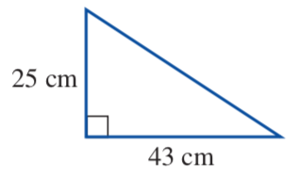
a.

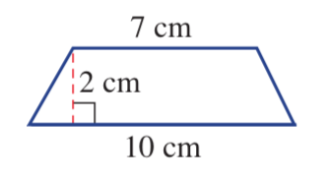
b.

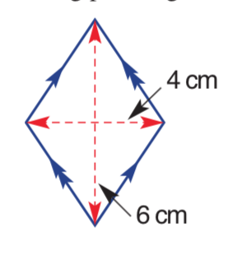
c.

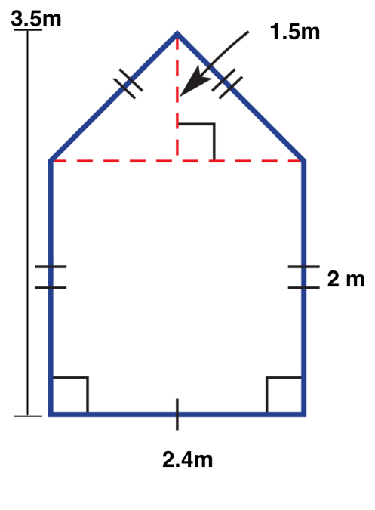
d.

Question 8 4 marks

Find the volume of these shapes.

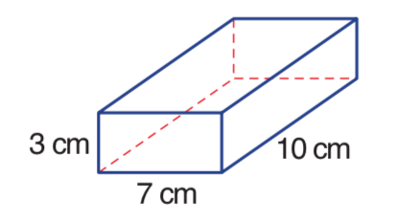

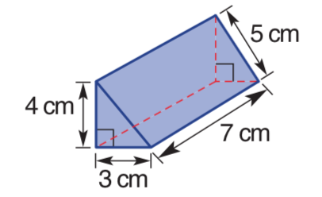

Question 9 12 marks

Farmer Kath is building a new water tank and needs to know how much metal to order, and how much water it will hold.
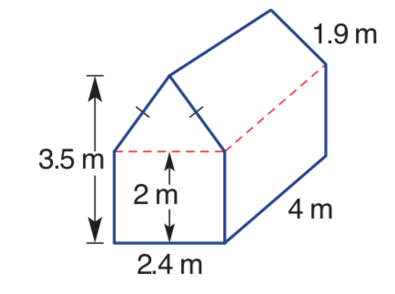
- Find the total surface area of the design below.

- Find the volume of the water tank.

- Find the total capacity of the water tank, if 1m³ = 1000L

- Farmer Kath goes to the bank and gets a simple interest loan of $10,500 to pay off the tank, at a rate of 6.2% for 5 years.
- What is the interest amount that farmer Kath has to pay?

- What is the gross (total) amount that Farmer Kath has to pay off after 5 years?

- If Farmer Kath pays off the loan with $50 a week, how much would she still owe after the 5-year period? (52 weeks in a year?)

